**EXHAUSTIVE ANALYSIS OF INDIAN AGRICULTURE USING POWER BI**

**INTERNSHIP PROJECT REPORT(DAY-1)**

**STEP1:** Extract the data from data source (excel, CSV, text, database file) using power Bi

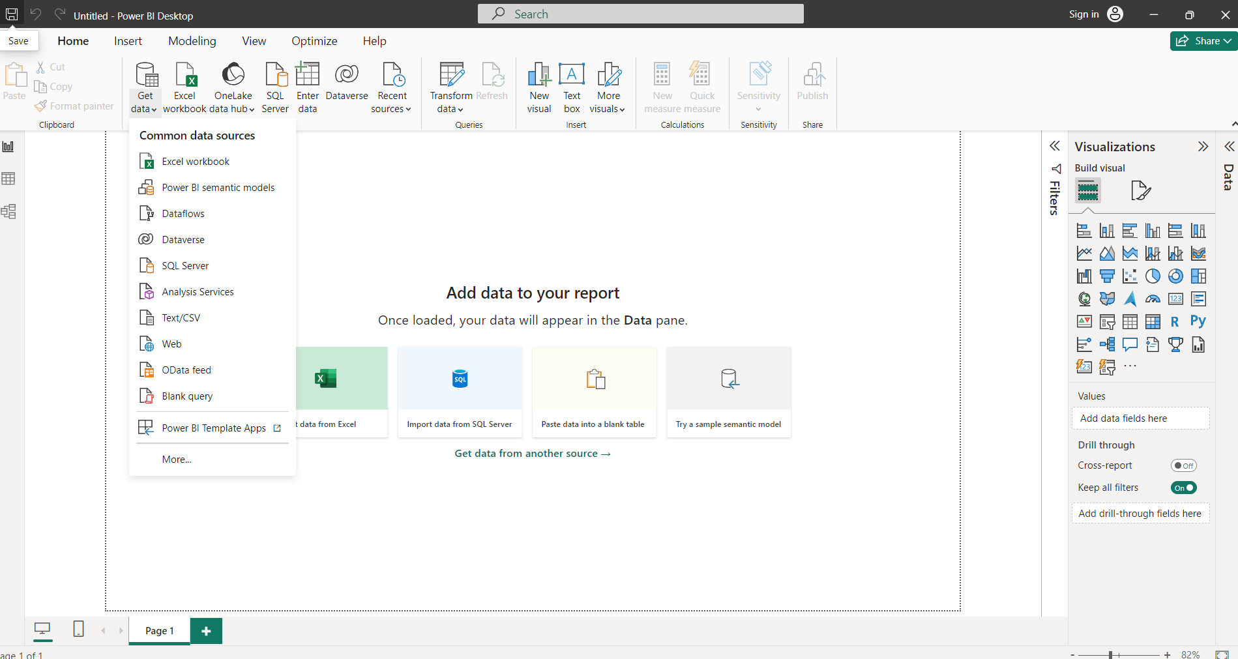

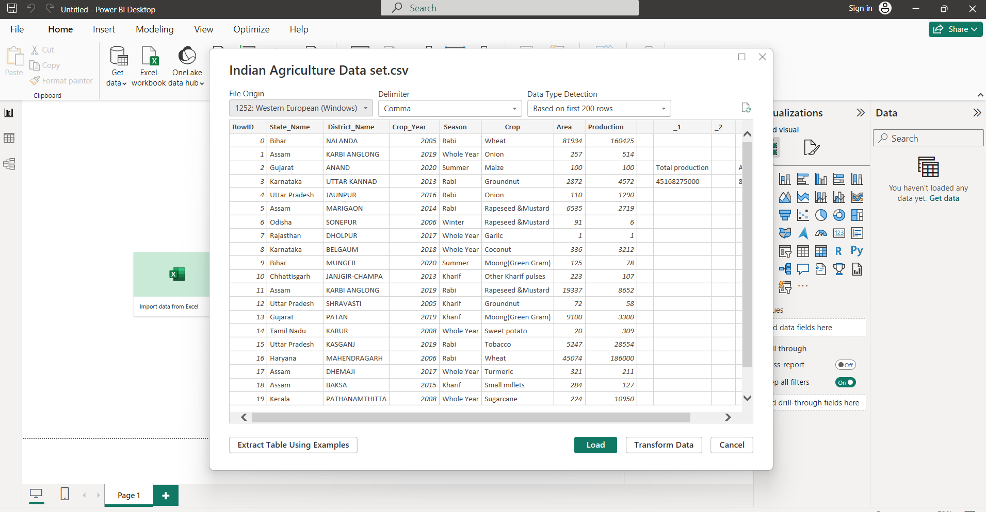

**STEP2:** Transform the data (preprocessing and data cleaning). Removed Null values, blank spaces and unnecessary columns.

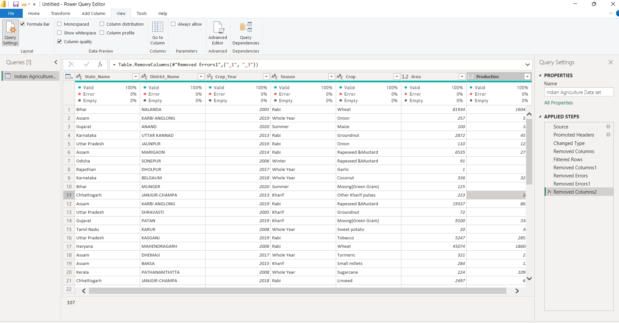

**STEP3**: Load the cleaned data for data analysis. We can see the report view also below attached image.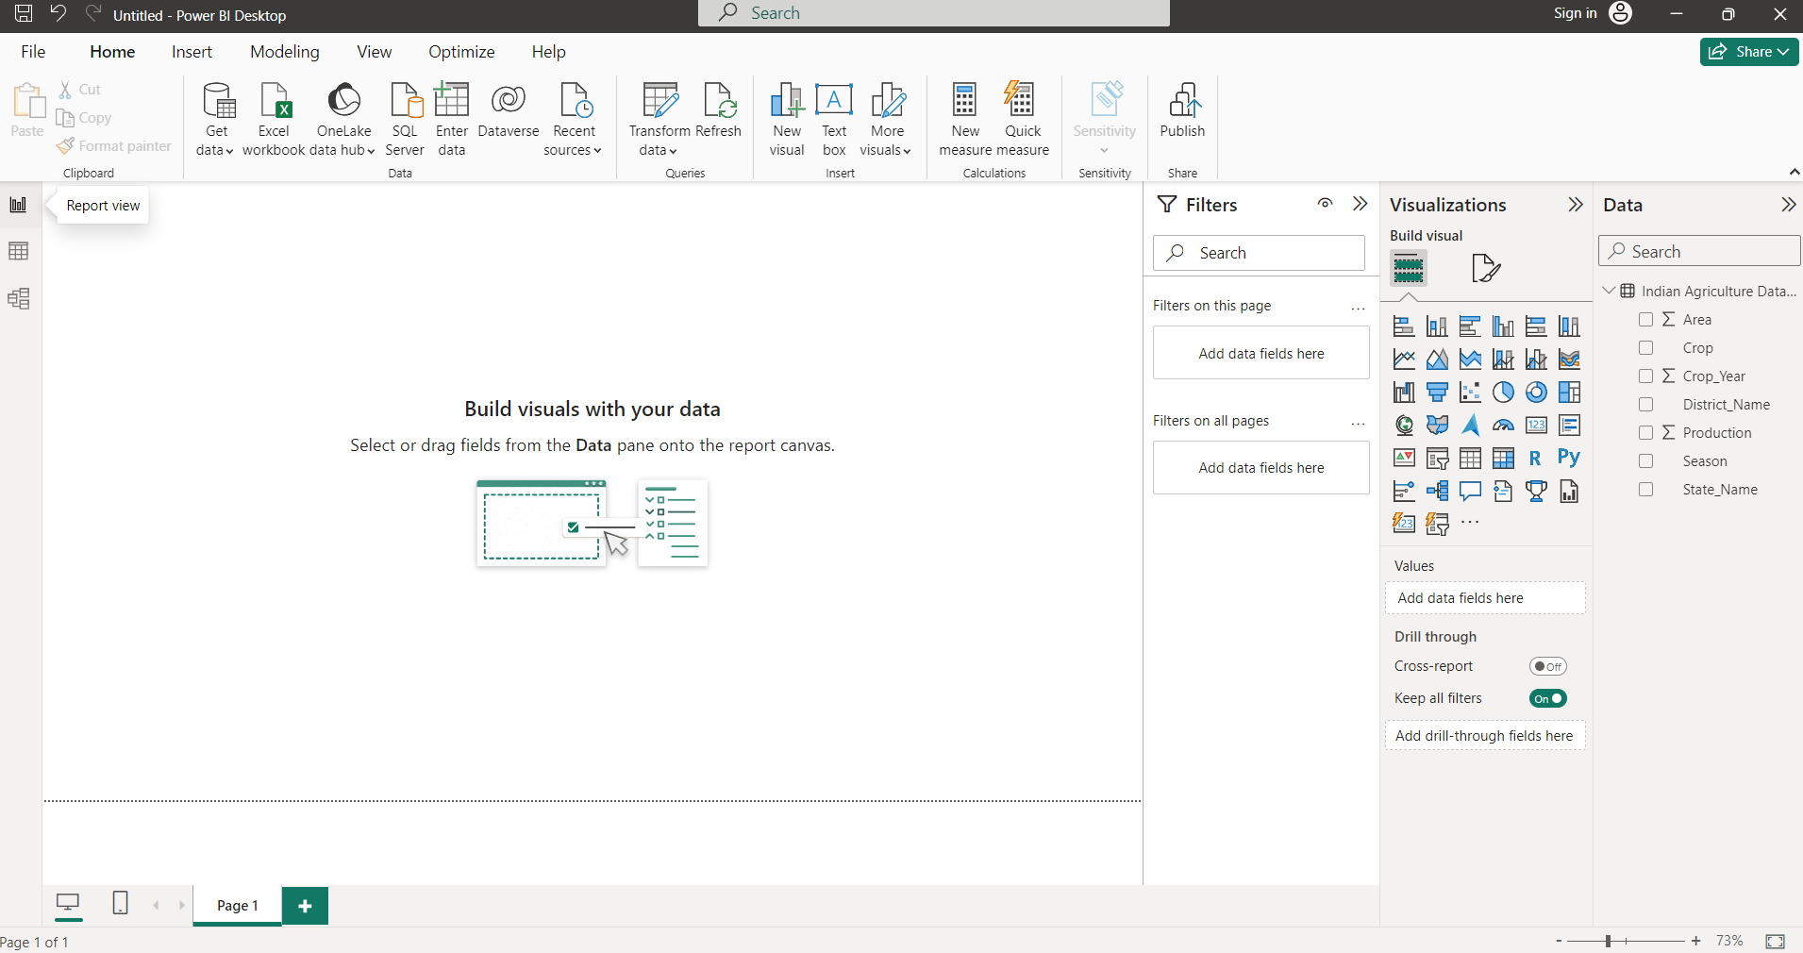

**STEP4:** Table view and report View

